*Investigating Variability in Baking*

Stat 7220, Dr. Kane

Kennesaw State University

Liz Ragsdale

9 out of 10 Good Experiment Practices Used

**Background:**

A common criticism of baking is that recipes have to be followed exactly as listed, otherwise the bake risks undesired variations from the intended outcome. Measurements, temperatures and even resting times can all effect the final result of a bake due to the chemical process that the ingredients undergo during the baking process. So, then the question becomes which changes have a noticeable impact? Where can a baker compromise in recipes but maintain similar results and what steps should never be skipped? This experiment aims to identify answers to those questions in regards to a few selected factors when baking cookies.

**Design:**

Specifically, this experiment seeks to determine if the following variations have a noticeable effect on the finished baked good. The first factor being if changes in the amount of chosen fat ingredient of the recipe, butter, affects the outcome. The second being if having the dough rest in a cool environment prior to baking effects the outcome[1], and if so, does the length of the chill time affect the final product?

These factors were chosen for differing reasons. Variation in butter was determined due to existing information about differing which fat is used in baking, the role of butter in a cookie dough and the level of familiarity the baker has using butter over other fat options in the bake. Fats serve an important purpose in baking for two main reasons: first, most fat in a batter encourages more gluten bonds to form which adds structure to the bake (Crosby, 411). Secondly, fats molecules bond to sugar molecules, creating beta-prime crystals that hold in air, which prevents bakes from being dense (Crosby, 396). Melted butter, as used for this experiment, adds one more important effect in additional moisture in the dough which helps sugar bond to the batter and keeps the texture chewier when baked (Crosby, 410). Given the information available, a difference in the outcome of the cookie as a result of change in butter amount is extremely likely, however that data usually focuses on texture and flavors of the final outcome while this experiment is focused on measuring a more quantifiable variable (Crosby, 411). The original recipe being modified for this experiment calls for 1/2 cup of butter per batch of cookies and will be varied into a batch using 1/3 cup and 2/3 cup for the two groups in the experiment. Each batch results in 12 cookies, per the original recipe.

The factor of differing oven batches based on a variety of different cookies recipes using a variety of instructions for the period between completing the dough and measuring it out to bake in the oven. The original recipe this experiment is using calls for no refrigerator chill time at all, while others might ask for 15 minute and in an extreme end, an entire day of chill time before baking (Saffitz, 2021). This experiment will be splitting the doughs into 3 different baking groups: batch 1 has no chill time, batch 2 has 15 minutes and batch 3 has 30 minutes, with each oven batch containing 8 total cookies each. Timings were determined based on baking and cooling times of prior batches and maximizing the chill time available within the experiment time frame.

The resulting variable being measured from this experiment is the diameter of the final product after each has cooled. The goal is to maximize the width of the cookies, as a traditional cookie is a semi-flat disc shape, rather than a dense ball that resembles the baked dough. Prior research supports this as it connects the shape to the idea conditions for developing textures and flavors traditionally preferential in a tasty cookie (Crosby, 416). Height was considered as an alternative response variable for this experiment, but length was determined to be more reliable for accurate measurements. Given the components and plan for the experiment, the data is to be assessed as a replicated, balance 2 factor fixed ANOVA, with 24 total cookies and 4 replicants.

**Measurement Evaluation:**

As mentioned in the design section, the original recipe the experiment is based on uses ½ cup of butter and the equivalent of oven batch 1’s resting time. More details about the baking process and equipment list are in appendix A. Based on prior bakes completed by the sole baker using this recipe and equipment, the final product is reliably consistent sized cookies as long as consistent measurement of dough is used.

During the experiment bakes, all batches were baked between 10-12 minutes until completely baked, so all oven batches vary slightly in bake time from each other but bake time is identical between replicants in each oven batch. It is also worth noting during the experiment itself, the original roll of parchment paper that was being used for lining the baking sheet ran out. Instead of opening a new roll and potentially introducing a new factor, the used parchment sheet was reused for all oven batches. The diameter length of each cookie is to be measured via ruler in centimeters at the spot of the largest diameter. The same ruler is used for all measurements and recorded in an excel spreadsheet alongside the factor grouping information.

**Data Collection Plan:**

To ensure as little variation outside of stated factors as possible, several steps were taken. The materials and equipment used were standardized across the experiment: same oven, baking sheet, parchment paper, ruler and dough scoop we used across all factor levels. All the bowls used for mixing ingredients were the same size and material. Ingredients were all sourced from the same source to ensure consistent quality: flour, cocoa, sugars from the same bag, eggs, and butter from the same batch. The differing butter amount batches were created at the same time by the same person to ensure experiment room conditions and baker’s efforts were uniform across all groups.

Once differing butter doughs were created, 12 dough balls were measured out from each butter batch and randomly assigned to fill each of the 3 oven groups using a random number generator. Each oven group received 4 1/3 cup butter cookies and 4 2/3 cup butter cookies. As for the baking process, oven batch 1 went straight to bake in the oven while the other two batches went to chill in a refrigerator. All replicants undergoing the chill period were chilled on the same level of the same refrigerator for the same about of time per oven batch.

It is worth noting no pilot test was directly done due to time and financial constraints. However, there is sufficient research to show there will be significant difference in at least the butter amount factor as mentioned in the design and background sections.

**Figure 1: Image of the final baked and cooled cookies from each grouping**

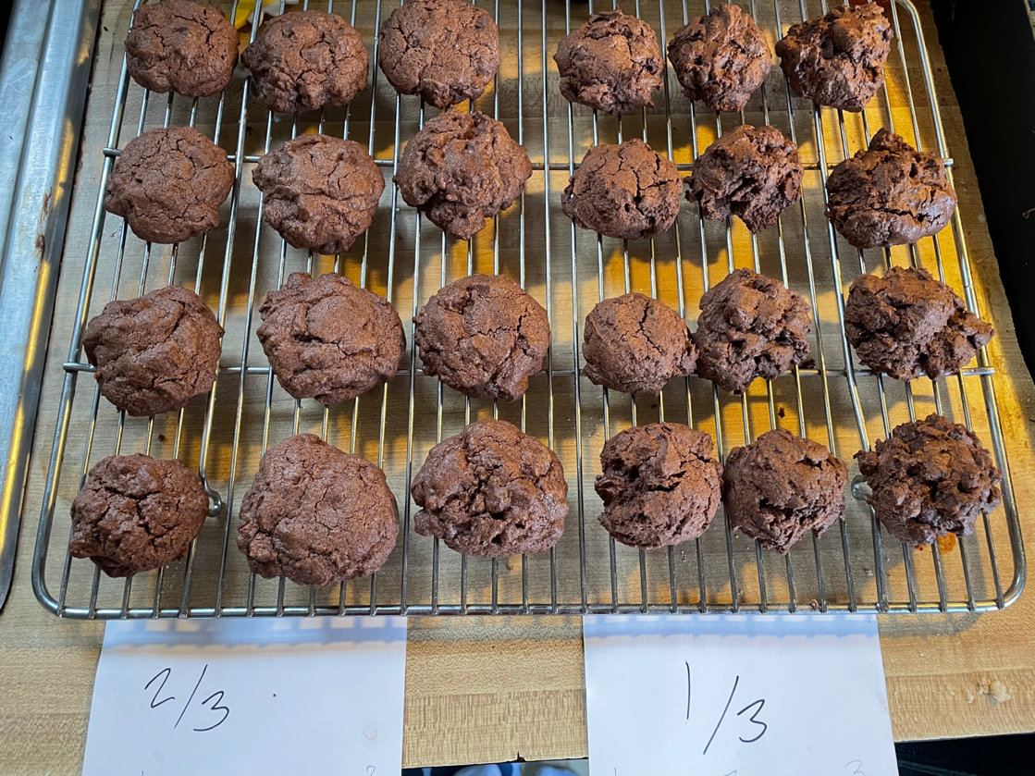

Figure 1 note: The left half is made with 2/3 cup of butter, right half made with 1/3 cup of butter. Each column denotes a different oven batch: (from left to right) columns 1 and 4 are oven batch 1, columns 2,5 are oven batch 2 and columns 3,6 are oven batch 3.

**Results:**

Using the data collected from the experiment process to generate a general linear model of each factor and the comparison of the factors. Both factors and the comparison were found to be less than the α = 0.005, so further analysis is going to be using the interaction of the two factors without need of pooling factors. This conclusion is supported by the data visualization in figure 2, showing the comparison groups trended towards differing length groups.

*Ho:* factor groups and the comparison groups are equal

*Ha:* the factor groups and comparison groups are not equal

**Figure 2: Scatterplot of grouped data**

**Figure 3: Analysis of Variance using α = 0.05**

|  |  |  |  |  |  |  |  |
| --- | --- | --- | --- | --- | --- | --- | --- |
| **Source** | **DF** | **Seq SS** | **Contribution** | **Adj SS** | **Adj MS** | **F-Value** | **P-Value** |
| oven batch | 2 | 1.6300 | 17.44% | 1.6300 | 0.81500 | 8.77 | 0.002 |
| butter amount | 1 | 5.3204 | 56.93% | 5.3204 | 5.32042 | 57.26 | 0.000 |
| oven batch*butter amount | 2 | 0.7233 | 7.74% | 0.7233 | 0.36167 | 3.89 | 0.039 |
| Error | 18 | 1.6725 | 17.89% | 1.6725 | 0.09292 |  |  |
| Total | 23 | 9.3462 | 100.00% |  |  |  |  |

To confirm the data meets the assumptions for the ANOVA, a residual analysis of the standardize residuals is performed. Figures 3 and 4 show the assumption of normality is met through probability plots and the Anderson darling value > 0.05. The residual plots versus the factors show no concerning pattern or outliers, which is also represented in the versus fits plot and the versus order shows no signs run order effecting results. Therefore, it can be assumed that all assumptions are met for the analysis.

**Figure 4: Four-in-One Plot of Standardized Residuals   
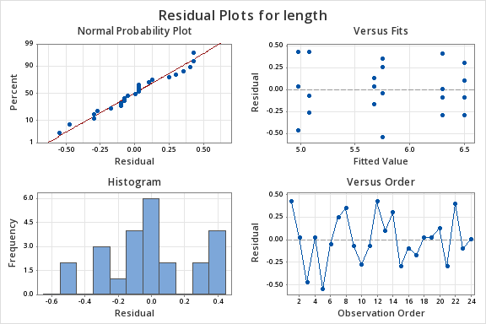**

**Figure 5: Probability plot of Standardized Residuals   
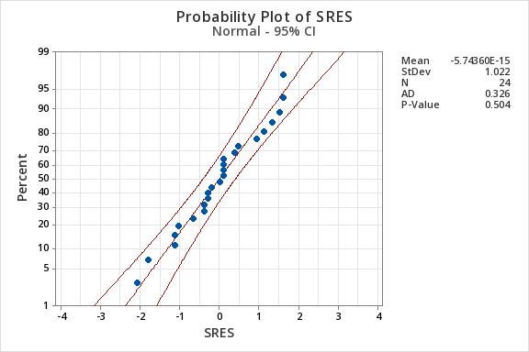**

**Figures 6-8: Residual Plots Against Factors**

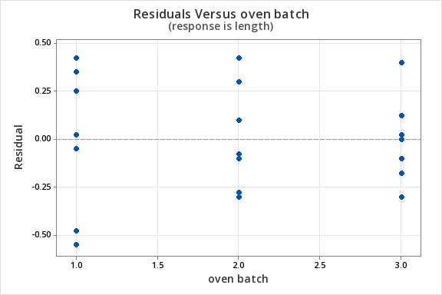

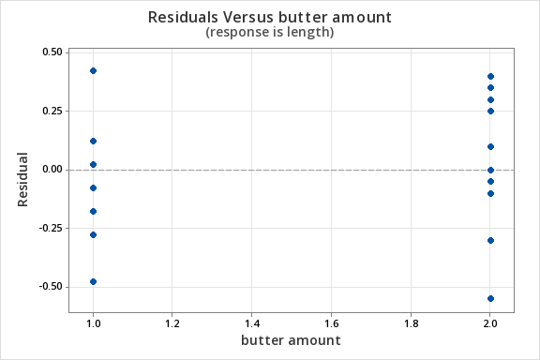 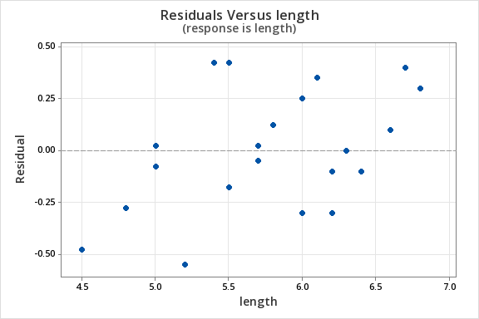

Since the residual analysis showed the data met the assumptions for normality and homogeneity, a Tukey’s comparison of means can be performed to determine the performance of the groups and which groups are statistically similar. Since the comparison between oven batch and butter amount was statistically significant, the Tukey’s test will be using the comparison groupings. Figure 8 shows the results from the analysis, group [2,2] was similar to group [3,2], with that grouping having the highest means of all of the pairings. Based on the group rankings, The higher butter amount resulted in better length over the 1/3 cup of butter in every group. Additionally, the 2nd and 3rd oven batches resulted in larger cookies than the 1st oven batch. There is a difference of 1.64 standard deviations between the factors, indicating a large difference between factor groups.

**Figure 8: Tukey Comparison of Means Grouping Method and 95% Confidence**

|  |  |  |  |  |  |  |
| --- | --- | --- | --- | --- | --- | --- |
| **oven batch*butter amount** | **N** | **Mean** | **Grouping** | | | |
| 2 2 | 4 | 6.500 | A |  |  |  |
| 3 2 | 4 | 6.300 | A | B |  |  |
| 1 2 | 4 | 5.750 |  | B | C |  |
| 3 1 | 4 | 5.675 |  | B | C |  |
| 2 1 | 4 | 5.075 |  |  | C | D |
| 1 1 | 4 | 4.975 |  |  |  | D |

Means that do not share a letter are significantly different.

**Conclusions:**

This experiment resulted in the following conclusions based on the data acquired:

* Altering the amount of butter used in the recipe led to significantly different results.
* Having 15 or 30 minutes of rest time in a refrigerator before baking leads to a significant difference in cookie size than having no chill time at all.
* To get a cookie with ideal spread while baking, use a higher quantity of butter and chill the dough in a cool place for at least 15 minutes before baking.
* Bake time may have had an effect but would require further testing due to it being paired with chill time in this experiment.
* A follow up confirmation study is needed to ensure study results, as one was not performed here due to time and monetary constraints.

**Appendix A - Original Recipe, Ingredients and Equipment List:**

*For the sake of this experiment, this recipe for double chocolate chip cookies was replicated twice and used differing butter amounts as mentioned in the design and data collection sections*.

Baking Equipment:

* Conventional kitchen oven
* Aluminum baking sheet
* Parchment paper
* 2 large bowls
* Sieve
* Measuring cups & spoons
* Rubber spatula and/or whisk
* Cooling rack
* (optional) electric mixer

Ingredients (for about 12 cookies):

1 cup – all-purpose flour

1/3 cup - unsweetened cocoa powder

1/2 tsp – baking soda

1/2 tsp – salt

1/2 cup – unsalted butter

1/2 cup – light brown sugar

1/3 cup – granulated white sugar

1 - large egg

2 tsp – vanilla extract

1 cup – semisweet chocolate chips

Baking Directions:

1. Preheat an oven to 375 degrees. Line an aluminum baking sheet with parchment paper and set aside for later.
2. Sift flour, cocoa powder, baking soda and salt into a large bowl and mix.
3. In a separate bowl, melt and cool the butter. Mix in the light brown sugar and granulated sugar until just combined, then add the egg and vanilla extract until well combined. For this step and the next, an electric hand mixer may be easier, but is not required.
4. Pouring the wet ingredients into the dry, gradually combine the two mixtures until just combined with no dry spots visible and stir in the chocolate chips.
5. Chill dough in refrigerator for about 15 minutes
6. Scoop small balls of dough, about 1/8th cup / 2 Tbs sized and space them out onto the baking sheet with about 3 inches space between balls.
7. Bake 10-12 minutes until edges are firm and the tops are starting to look dry. Partially cool on baking sheet, then transfer onto a cooling rack.

**Appendix B – Citations:**

Crosby, G. (2012). *The Science of Good Cooking: Master 50 Simple Concepts to enjoy a lifetime*

*of success in the kitchen*. America’s Test Kitchen.

Kane, V.(2024). *Good Experimentation Practices 10th edition* (Referenced in footnotes)

Saffitz, C. (2021, April 29). *Claire Saffitz makes chocolate chip cookies | dessert person*. YouTube. https://www.youtube.com/watch?v=kPauR6tP_cg

**Appendix C – Data Table with standardized residuals:**

Minitab was used for all data analysis.

|  |  |  |  |  |
| --- | --- | --- | --- | --- |
| **run order** | **oven batch** | **butter amount** | **Length (cm)** | **SRES** |
| 1 | 3 | 1/3 cup | 5.7 | 0.09470274476207707 |
| 2 | 1 | 1/3 cup | 5 | 0.0947027447620737 |
| 3 | 1 | 1/3 cup | 5 | 0.0947027447620737 |
| 4 | 1 | 2/3 cup | 5.2 | -2.083460384765662 |
| 5 | 3 | 1/3 cup | 5.7 | 0.09470274476207707 |
| 6 | 1 | 2/3 cup | 6.1 | 1.3258384266690622 |
| 7 | 2 | 1/3 cup | 4.8 | -1.041730192382831 |
| 8 | 3 | 1/3 cup | 5.5 | -0.6629192133345294 |
| 9 | 3 | 1/3 cup | 5.8 | 0.4735137238103786 |
| 10 | 1 | 1/3 cup | 4.5 | -1.7993521504794407 |
| 11 | 3 | 2/3 cup | 6 | -1.136432937144908 |
| 12 | 1 | 2/3 cup | 5.7 | -0.1894054895241474 |
| 13 | 2 | 2/3 cup | 6.6 | 0.3788109790483016 |
| 14 | 3 | 2/3 cup | 6.2 | -0.3788109790483016 |
| 15 | 2 | 1/3 cup | 5 | -0.2841082342862245 |
| 16 | 2 | 2/3 cup | 6.2 | -1.136432937144908 |
| 17 | 2 | 1/3 cup | 5 | -0.2841082342862245 |
| 18 | 2 | 1/3 cup | 5.5 | 1.60994666095529 |
| 19 | 3 | 2/3 cup | 6.3 | 0 |
| 20 | 2 | 2/3 cup | 6.8 | 1.136432937144908 |
| 21 | 1 | 1/3 cup | 5.4 | 1.6099466609552866 |
| 22 | 3 | 2/3 cup | 6.7 | 1.515243916193213 |
| 23 | 2 | 2/3 cup | 6.4 | -0.3788109790483016 |
| 24 | 1 | 2/3 cup | 6 | 0.9470274476207606 |

1.